**FOOD SAFETY AND SANITATION 2019/2020**

**Two (2) hours CACFP Training**

**(Reminder Licensed Assistant must complete training)**

*In accordance with Federal civil rights law and U.S. Department of Agriculture (USDA) civil rights regulations and policies, the USDA, its Agencies, offices, and employees, and institutions participating in or administering USDA programs are prohibited from discriminating based on race, color, national origin, sex, disability, age, or reprisal or retaliation for prior civil rights activity in any program or activity conducted or funded by USDA.*

*Persons with disabilities who require alternative means of communication for program information (e.g. Braille, large print, audiotape, American Sign Language, etc.), should contact the Agency (State or local) where they applied for benefits. Individuals who are deaf, hard of hearing or have speech disabilities may contact USDA through the Federal Relay Service at (800) 877-8339. Additionally, program information may be made available in languages other than English.*

*To file a program complaint of discrimination, complete the USDA Program Discrimination Complaint Form, (AD-3027) found online at: http://www.ascr.usda.gov/complaint_filing_cust.html, and at any USDA office, or write a letter addressed to USDA and provide in the letter all of the information requested in the form. To request a copy of the complaint form, call (866) 632-9992. Submit your completed form or letter to USDA by:*

*(1) mail: U.S. Department of Agriculture   
Office of the Assistant Secretary for Civil Rights   
1400 Independence Avenue, SW   
Washington, D.C. 20250-9410;*

*(2) fax: (202) 690-7442; or*

*(3) email:* [*program.intake@usda.gov*](mailto:program.intake@usda.gov)*.*

*This institution is an equal opportunity provider.*

Resources:

YFC 2018

The Partnership for Food Safety Education; www.fightbac.org

USDA Food Safety and Inspection Service

Academy of Nutrition and Dietetics—www.homefoodsafety.org

*To support you in protecting your family and your childcare, the Partnership for Food Safety Education shares the most popular food safety myths and facts. Please share this information with your childcare families and friends.*

[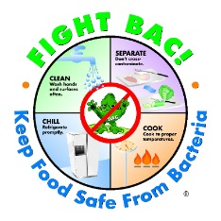](https://www.google.com/url?sa=i&rct=j&q=&esrc=s&source=images&cd=&cad=rja&uact=8&ved=2ahUKEwj1m6L80tLiAhVpplkKHZFcA7UQjRx6BAgBEAU&url=https%3A%2F%2Fwww.foodsafetynews.com%2F2016%2F09%2Fhow-may-do-you-know-top-10-food-safety-myths-and-facts%2F&psig=AOvVaw2WUHILpxR5CqbsbSNyU84P&ust=1559834494569549)

USDA provides One hundred percent of the funding for this program and, therefore, USDA, the Massachusetts Department of Elementary and Secondary Education, Office may freely copy any publication for Food and Nutrition Programs (FNP) and by any other institutions Under the Child and Adult Care Food Program.

[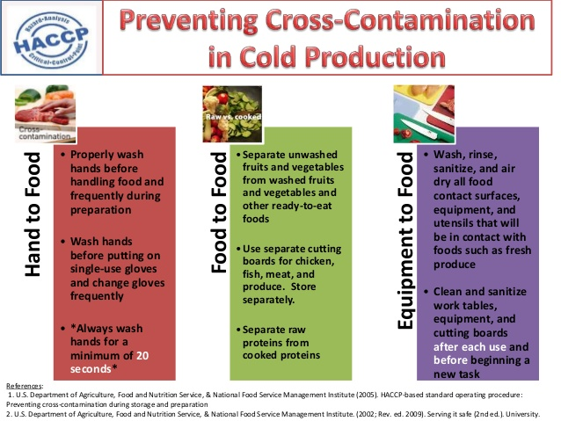](https://www.google.com/url?sa=i&rct=j&q=&esrc=s&source=images&cd=&ved=2ahUKEwiM55T31NLiAhUurlkKHZhhCjIQjRx6BAgBEAU&url=https%3A%2F%2Fwww.slideshare.net%2FMinnaSabbahi%2Fpreventing-crosscontamination-53932898&psig=AOvVaw1mK1POt5ENzvU1W2qZKCnz&ust=1559835120634043)

**Myth:**  “Cross contamination doesn’t happen in the refrigerator...it is too cold in there

for germs to survive!”

**Actually**: Some bacteria can survive and even grow in cool, moist environments like a

refrigerator!

In fact, Listeria Monocytogenes grows at temperatures as low as 35.6° F! A recent study from the National Sanitation Foundation (NFS) revealed that the refrigerator produce compartment was one of the “germiest” places in the kitchen, containing both Listeria and Salmonella bacteria.

* Keep fresh fruits and vegetables and all ready to eat foods separate from raw meat, poultry, seafood, and eggs.
* Clean your refrigerator regularly with hot water and soap. Clean up food and beverage spills immediately to reduce the risk of cross contamination.
* Remove and clean produce and other bins in your refrigerator often with hot water and liquid soap. Rinse thoroughly and dry outside of refrigerator.
* Do not forget to clean refrigerator walls and the undersides of shelves!

**Myth:** I know my refrigerator is cold enough-I can feel it when I open in! And, I have a

dial to adjust the temperature.”

**Actually:** Unless you have thermometers in your fingers, you need to keep and check a thermometer in your refrigerator to ensure the temperature is at or below 40° F.

* Almost half of home refrigerators have been found to be at temperatures above 40° F.
* Refrigerated foods held at above 40° F. put foods in the “danger zone’ where harmful bacteria can multiply and grow putting your family and child care children at risk.
* The danger zone for perishable foods is between 41—135° F. Perishable foods should not be left in this temperature zone for more than 1-2 hours.
* Refrigerator temperature should be between 35-40° F to slow the growth of bacteria.
* Cold temperatures do not kill bacteria.

**Myth:** I do not need to rinse and dry fruits like melon that I do not eat the rind. I only

eat the part on the inside

**Actually**: Even though you are not eating the rind of the melon, there are many ways for pathogens on the outside of the melon to contaminate the edible portion.

A knife or peeler passing through the rind can carry pathogens from the outside into the flesh of the fruit. The rind also touches the edible portion when the fruit is arranged or stacked for serving.

[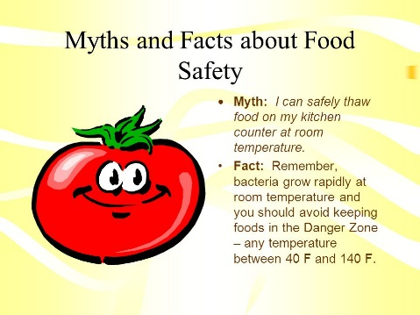](https://www.google.com/url?sa=i&rct=j&q=&esrc=s&source=images&cd=&ved=2ahUKEwiq45Wt09LiAhXOjFkKHeFVBmMQjRx6BAgBEAU&url=https%3A%2F%2Fslideplayer.com%2Fslide%2F6224982%2F&psig=AOvVaw2WUHILpxR5CqbsbSNyU84P&ust=1559834494569549)

* Play it safe and rinse all your fruits/vegetables just before serving.
* Even bananas should be rinsed before peeling.
* Rinse under running tap water while rubbing by hand or scrubbing with a clean brush.
* Drying fruits and vegetables with a clean cloth or paper towel is an important step.
* Research has found that the drying step further reduces the level of harmful bacteria on the surface of fresh produce.

**Myth:** “I eat a vegetarian diet; I don’t need to worry about food poisoning.”

**Actually:** Like any food, fruits and vegetables may carry the risk of foodborne illness due to handling and cross-contamination.

Food poisoning is not only associated with meats and meat products. High-risk non-meat foods include rice, tofu, lentils, lettuce and other vegetables, coconuts, soft fruits, and herbs. All these foods have been part of food poisoning outbreaks.

* Foods that require little or no cooking can provide a perfect breeding environment for bacterial growth.
* Always rinse all produce under running tap water just prior to serving.
* Do not use detergent or bleach to wash fresh fruits or vegetables as these products are not intended for consumption and may leave harmful residue on foods.

**Myth:** “Leftovers are safe to eat until they smell bad.”

**Actually:** Smell is not an indication of whether a food is safe to eat!

There are many different types of bacteria...some that cause illness in people and some that do not. **The types of bacteria that cause foodborne illness do not affect the taste, smell, or appearance of food!**

* Properly store and date leftovers.
* Freeze or throw away refrigerated leftovers within 3-4 days even if they smell and look fine.
* If you are not sure how long leftovers have been in the refrigerator, toss them out.
* If you do not know how old your leftovers are, remember: when in doubt, throw them out!

**Myth:** “Freezing food kills harmful bacteria that can cause food poisoning.”

**Actually:** Bacteria can survive freezing temperature. Freezing is not a method for making food

safe to eat

Freezing food renders, any bacteria present inactive, but does not kill any bacteria. When food is thawed, bacteria will still be present and may begin to multiply. You must handle defrosted foods with the same care as any perishable food.

* Always defrost food safely. Defrost in the refrigerator, microwave oven, or in a cold-water bath, (water must be changed frequently). DO NOT DEFROST FOODS ON THE COUNTER!
* Foods defrosted in the microwave or cold-water method should be cooked immediately after thawing.
* Cooking food to the proper internal temperature is the best way to kill harmful bacteria.
* Always read and follow the package cooking instructions.
* Use a thermometer to measure the internal temperature of cooked foods.

**Myth:** “If I microwave food, the microwaves kill the bacteria so the food is safe.”

**Actually:** Microwaves are not what kill bacteria– it is the heat

Microwave ovens are great time-savers and will kill bacteria in foods when heated to a safe internal temperature. However, foods can cook unevenly because the food may have an irregular shape or vary in thickness. Even microwave ovens using a turntable can cook unevenly and

leave cold spots where harmful bacteria can survive.

[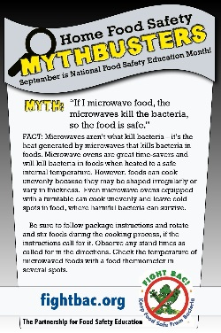](https://www.google.com/url?sa=i&rct=j&q=&esrc=s&source=images&cd=&ved=2ahUKEwix6MCT1tLiAhWFr1kKHVGIBbgQjRx6BAgBEAU&url=https%3A%2F%2Fwww.pinterest.com%2Fpin%2F432345632949682722%2F&psig=AOvVaw1d0UrXmSNaQfxdDpgEd1sy&ust=1559835457076943)

* Be sure to follow the package instructions, rotate, and stir foods during the cooking process, if the instructions call for it.
* Alternatively, arrange food evenly in a covered dish and add some liquid if needed. The moist heat that is created will help kill bacteria and ensure a more even cooking.
* Observe any stand times as called for in the directions.
* To be safe, check the temperature of microwaved foods with a food thermometer in several spots.

**Myth:** “Once a hamburger turns brown in the middle, it is cooked to a safe internal

temperature.”

**Actually:** You cannot use visual cues to determine whether a food has been cooked to a safe minimum internal temperature.

The ONLY way to know that food has been cooked to a safe minimum internal temperature is to use a food thermometer.

* Any cooked, uncured red meats – including pork – can be pink, even when the meat has reached a safe internal temperature.
* There are three important temperatures to remember when cooking meat or eggs at home: Eggs and all ground meats must be cooked to 160°F; poultry and fowl to 165°F; and fresh meat steaks, chops and roasts to 145°F.
* After you remove meat from a grill, oven, or other heat source, allow it to rest for 3-5 minutes. During the rest time, its temperature remains constant or continues to rise.

**Myth:** “Putting chicken in a colander and rinsing it with water will remove bacteria like

Salmonella.”

**Actually:** Rinsing chicken in a colander or in your kitchen sink will **not** remove bacteria.

In fact, it can spread raw juices around your sink, onto your countertops, and onto ready-to-eat foods! Bacteria in raw meat and poultry can only be killed when cooked to a safe minimum internal temperature as measured by a food thermometer.

* Save yourself the messiness of rinsing raw poultry. It is not a safety step and can cause cross-contamination.
* You can wipe raw poultry with paper towels, being careful to dispose of the paper towels right away.
* You can still marinate your poultry, but remember, the marinade or whatever liquid you use will be contaminated with the same bacteria present on the poultry.
* Cook poultry to a safe minimum internal temperature of 165° F as measured by a food thermometer.

**Myth:** “It is OK to wash bagged salad greens if I want to. There’s no harm.”

**Actually:** Rinsing greens labeled “ready-to -eat” or “triple washed” will not enhance safety, in fact, it increases the potential for cross contamination.

Pathogens that may be on your hands or on your kitchen surfaces could find their way into your greens. Triple-washed or ready’-to-eat greens have been washed in controlled environments that you cannot replicate. Some thoughts on purchasing leafy green vegetables:

* At the store, select packages that are refrigerated, have the latest “use by” dates, and show no signs of damage, spoilage, wetness, or slime on the leaves. The leaves should look dry and
* crisp.
* Do not assume packaged organic greens are safer.
* At home, keep them refrigerated, and eat them as soon as possible.

