Clarendon Early Education Services, Inc.
Breakfast Bonanza
The Importance of Breakfast for Growing Children
2 Hours Nutrition 2017/2018 Training

USDA Non-Discrimination Statement:
In accordance with Federal civil rights law and U.S. Department of Agriculture (USDA) civil rights regulations and policies, the USDA, its Agencies, offices, and employees, and institutions participating in or administering USDA programs are prohibited from discriminating based on race, color, national origin, sex, disability, age, or reprisal or retaliation for prior civil rights activity in any program or activity conducted or funded by USDA.
Persons with disabilities who require alternative means of communication for program information (e.g. Braille, large print, audiotape, American Sign Language, etc.), should contact the Agency (State or local) where they applied for benefits. Individuals who are deaf, hard of hearing or have speech disabilities may contact USDA through the Federal Relay Service at (800) 877-8339. Additionally, program information may be made available in languages other than English.
To file a program complaint of discrimination, complete the USDA Program Discrimination Complaint Form, (AD-3027) found online at: http://www.ascr.usda.gov/complaint_filing_cust.html, and at any USDA office, or write a letter addressed to USDA and provide in the letter all of the information requested in the form. To request a copy of the complaint form, call (866) 632-9992. Submit your completed form or letter to USDA by:
(1) mail: U.S. Department of Agriculture
Office of the Assistant Secretary for Civil Rights
1400 Independence Avenue, SW
Washington, D.C. 20250-9410;
(2) fax: (202) 690-7442; or
(3) email: program.intake@usda.gov.
This institution is an equal opportunity provider.
Resources: Thank you to Provider Resources, Inc. 2014
Updated September 2017
One hundred percent (100%) of the funding for this program and publication is provided by USDA and, therefore, any publications may be freely copied by USDA, the Office for food and Nutrition Programs, and by any institutions under the Child and Adult Care Food Program (CACFP)
Provider Name ___________________________ Provider Number ______

This is a self-instruction course that deals with family child care programs which may provide care for infants, toddlers, preschoolers, and school age children..

The ideas presented in this course apply in a general way to all types of family child care environments. Providers should adjust the ideas and suggestions to their own specific circumstances.
This course is divided into two groups.
Group One: Demonstrates the components of a good breakfast and the physical and intellectual advantages a child gains when served such. Additionally, the example of the adult is discussed to show the impact it can have on children. Group one ends with a list of ways to make breakfast a success in your home.

Group Two: Contains fun food activities and recipes presented to make breakfast nutritious and fun.

The lessons are not designed to be hard, but rather to be instructive. The questions are not designed to rick you; but rather designed to help determine your understanding of the information contained in each group. The primary training goal is to provide good information which will assist in making your very challenging job a bit easier.

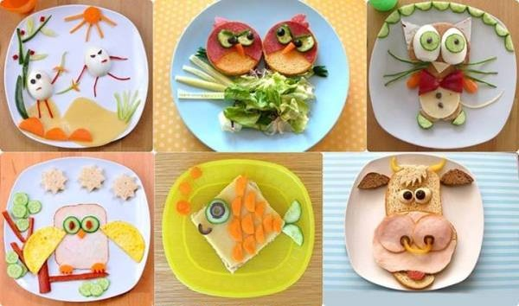

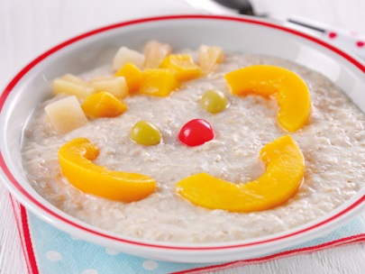

The Importance of Breakfast

- You will identify the components of a good breakfast.
- You will identify how good nutrition affects the mind and body.

Group one demonstrates the components of a good breakfast and the physical and intellectual advantages a child gains when served such. Additionally, the example of the adult is discussed to show the impact it can have on children. Group one ends with a list of ways to make breakfast a success in your home.

Components of a Good Breakfast

According to the USDA food program standards, breakfast should consist of:
Fluid Milk,
Fruit, Vegetable or portions of both and a
Whole grain-rich or enriched bread product

Calcium & Vitamin D: Milk is fortified with Vitamin D because it helps the body absorb calcium. Vitamin D also helps the body maintain healthy bones. In addition, your body makes Vitamin D when your skin is exposed to sunlight. There are very few foods that naturally contain Vitamin D, which is the reason foods are fortified with the vitamin.

Calcium plays an important role because it helps the body develop and maintain strong bones and teeth. Although calcium is important for people of all ages, it I especially important for children whose teeth and ones ae still developing. Everyone needs calcium before birth and throughout life. Calcium helps to maintain a normal heart rhythm, enables muscles to work, transmits nerve impulses, and aids in blood clotting. No matter the person’s age, calcium plays an important role in development as well as maintaining good health. The body takes calcium from food and as a result if a person doesn’t get enough calcium from food the body cannot produce it and will actually withdraw calcium from you bones.

Calcium can also be found in broccoli some dark leafy greens, almonds, sardines and dairy products. Many other foods today are fortified with calcium such as orange juice.

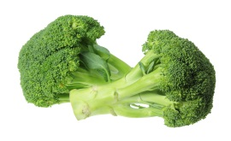
Where does the word “Breakfast” come from? The word breakfast comes from the Middle English word brekfast, which means “to break the fast”. That is exactly what you do when you eat your first meal of the morning; you break your overnight fast. Think about how you feed the children during the day. Toddlers and pre-school children burn energy at a very fast pace and as a result they get hungry every few hours. Most childcare homes feed the children a breakfast from 7:30-8:30, morning snack from 10:00 - 10:30, a
Lunch from 12:00-1:00, and an afternoon snack from 3:00-3:30. Some providers vary this schedule depending upon the ages of the participating children. Once the children return home, they may not have dinner until 6:00 or 7:00 pm. If a child doesn't have a late evening snack, their bodies enter a fasting stage. The food they eat during the day fuels their body, giving it the energy it needs in order to function. During the evening hours, however, the body uses the stored vitamins and nutrients to repair and build muscle and bone
_________________________________________________________________________
Vitamins A & C: Fruit/Vegetables and fruit/vegetable juices play an important role in giving young children the essential vitamins and nutrients to start their day. Vitamin A is important to the body because it promotes eyesight and helps us see in the dark. Vitamin A assists with the separation of skin cells and mucous membranes. It helps the body fight off infection and sustain the immune system, as well as supporting growth and remodeling of bone. Vitamin A may also reduce the risk of certain cancers. Children, who do not eat a wide variety of foods that are high in Vitamin A, are more prone to infections such as ear infections, the common cold, strep throat sinusitis and gastrointestinal problems. Fruits and vegetables that are yellow/deep orange or red in color have the highest amounts of Vitamin A. Examples include: apricots, peaches, nectarines, cantaloupe, carrots, mango, pumpkin, sweet potato and many forms of winter squash.

Vitamin C helps to maintain healthy gums, aids in the production of collagen, which is important for connective tissue, and assists the body in absorbing iron and folate from plant sources. This is important because young children need to maintain healthy gum tissue since they are in the process of dental development. Baby teeth are formed and are coming in and as they age, children lose baby teeth and eventually get their adult teeth. Children who do not have healthy gum tissue could be at risk of damaging their teeth. As young children grow it is important for their connective tissue to be elastic and healthy while their bodies go through quick growth spurts. Their bones grow quickly and their connective tissue is the part of the body that helps keep joints and muscle attached to the bone. Vitamin C facilitates flexible joints that children need in order to be active. Lastly it helps the body absorb iron and folate, two very important minerals. Fruits and vegetable that are high in vitamin C are oranges, strawberries, tomatoes, and red peppers, but so are pineapples which are pale in color.

Iron is essential for young children because it helps prevent anemia. Children, who have low iron, tend to have less energy which is necessary to get through the day. Also, proper levels of iron help reduce the risk of lead poisoning in young children. Folate is a water-soluble B-vitamin. Deficiency can cause
Anemia by impairing red blood cell formation. Folate can be found in dark green leafy vegetable, and grains, it is also added synthetically to breakfast cereals. Young children who are deficient in folate may show slow growth development.

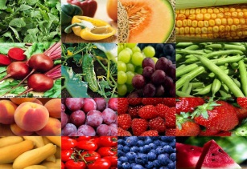
Whole Grain-Rich

At least one serving of grains per day must be whole grain-rich (7 CFR 226.20(a)(4)(i)(A)). Whole grain-rich foods are foods that contain 100 percent whole grains, or that contain at least 50 percent whole grains and the remaining grains in the food are enriched. This whole grain-rich requirement only applies to meals served to children it does not apply to infant meals.

Family day care homes can use the following as a simple checklist to determine if a grain is whole grain-rich. The food must meet at least one of the following:

- Whole grains are the primary ingredient by weight:
- Breads, cereals, and other non-mixed dishes: A whole grain is listed as the first ingredient on the product’s ingredient list or second after water. Some examples of whole grain ingredients are whole wheat, brown rice or wild rice, oatmeal, bulgur, whole-grain corn, and quinoa.

When a whole grain is not listed as the first ingredient, the primary ingredient by weight may be whole grains if there are multiple whole-grain ingredients and the combined weight of those whole grains is more than the weight of the other ingredients. For example, a bread may be made with three grain ingredients: enriched wheat flour (40% of grain weight), whole-wheat flour (30% of grain weight) and whole oats (30% of grain weight). This bread could meet the whole grain-rich criteria with proper documentation from the manufacturer or a recipe, for foods prepared by a CACFP day care home, because the combined weight of the two whole-grain ingredients (whole wheat and whole oats) is greater (60%) than the enriched wheat flour (40%), even though the enriched wheat flour may be listed first on the ingredient list. All grains in the food that are not whole grain must be enriched (e.g., enriched flour). Please refer to USDA’s Child Meal Pattern Breakfast for additional information for reimbursable meals.

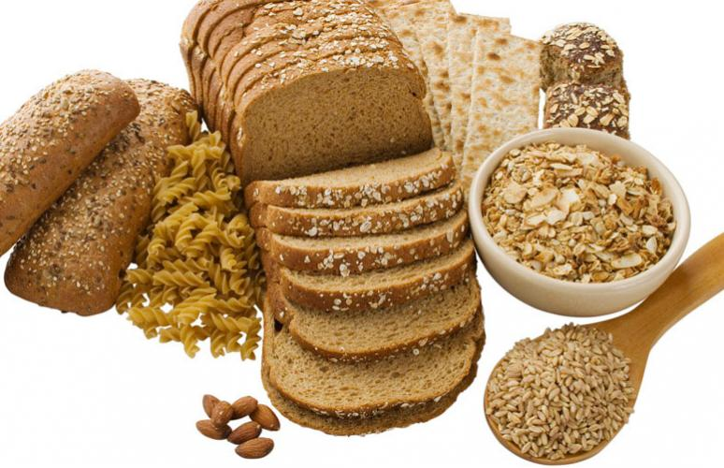

Physical and Cognitive Advantages

Eating a healthy breakfast prevents some adverse effects of fasting such as irritability and fatigue. It also establishes the tone for the next sixteen hours of the day. A nutritious breakfast fuels the child's body for a morning of play or school work. Think of all of the activity that young children expend during the day. They are jumping, running, climbing, swinging, throwing balls, and crawling. These activities consume a great amount of energy and calories. While performing these activities, the children are building their muscles and bones. The nutrients in the food they eat directly contribute to their activity level. A child, who does not eat a healthy breakfast, does not have the energy to perform necessary tasks. These children can become lethargic and listless, which in turn can affect their skill development.
Cognitively, food fuels the brain. A child with hunger in his/her stomach is not going to be able to focus, pay attention and concentrate on learning. Poor nutrition has been /inked to short attention span, poor memory, behavior problems, and distractibility/ity. In a study by Harvard University/Massachusetts General Hospital using children in early elementary school, children who ate a healthy breakfast had improved math grades, reduced hyperactivity, decreased absence/tardy rate, and improved social behaviors compared to children who rarely ate breakfast. The number of children skipping breakfast is increasing. According to a USDA study, 48% of girls and 32% of boys do not eat breakfast every day. In fact 35-40% of all Americans skip breakfast so adults are not role modeling the healthy behavior of eating breakfast daily.
The excuses are well known: no time, not hungry in the morning, trying to lose weight and dislike breakfast foods. Young children do not make up the nutrients missed when they skip breakfast. Lack of breakfast may result in a nutritionally inadequate diet that negatively influences learning. The hunger resulting from skipping breakfast may cause children to exhibit nervousness, irritability, disinterest in learning, listlessness and lack of concentration, all of which will interrupt a young child's proper growth and development. Many times when you start a new child, you need to retrain their eating habits. Young children today are familiar with eating high sugared cereals, donuts and pastries as well as juice drinks that are not 100% juice. These products may fill a child's belly and take away hunger but they do not contribute to the nutritional needs of the child. Today many pediatricians and nutritionists see children that are overweight but are nutritionally deprived. They are fed but suffer from malnutrition and its side­ effects.

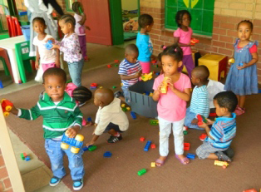

Smart Ways to Make Breakfast Successful

- Eat breakfast with the children. “Showing” teaches more than “telling”. The children will follow what you do.

- Some preparation the evening before may contribute to more relaxed morning routine.

- Break out of the boring routine. Try some creative recipe ideas.

- Don’t rush mealtime. In the morning children need time to adjust, especially if they did not sleep well the night before. Some children arrive at your house ready to eat; others need time to make the transition from home to childcare.

- Let the children help wherever and whenever possible. Children are more likely to try new foods if they are allowed to help prepare it. This could be your first morning activity with the children. Doing tasks such as pouring, stirring and mixing help develop small muscles which children use when learning to write.

- Also consider giving the children tasks such as setting out the plates, bowls, napkins, spoons, etc. Make sure the task is appropriate for the child’s age and skill level. Children as young as 2 ½ years old can set a table with unbreakable items.

- Get in a routine. Once in a routine the children know what you expect f them and they are usually eager to help and please. Make sure that you give them praise for doing a good job.

- Consider family style breakfasts. This means the food is placed in the middle of the table in serving dishes and the provider and children sit down at the table together. Allow the children to serve themselves, depending on age and skill level. This allows for a calm, relaxed mealtime where you can discuss the importance of healthy eating, the color and textures of food, their likes and dislikes and the enhancement of good table manner.

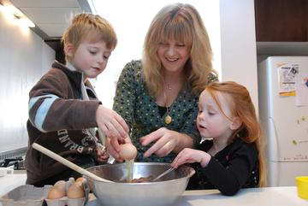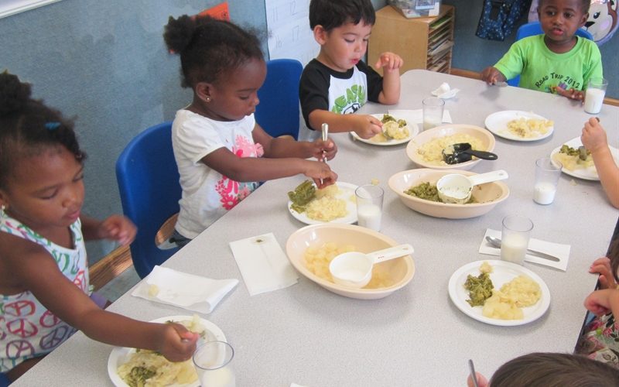

Group two: Demonstrates an understanding of how children develop good eating habits. Contains fun food activities and recipes presented to make breakfast nutritious and fun.

How do you get children who are accustomed to eating refined carbohydrates like donuts and sweetened cereal to eat healthy whole grains? Very slowly and slyly!

Toddlers are naturally curious; between the ages of one and two, most are willing to sample anything you place before them. Use this window of opportunity to introduce new flavors and textures. If a child rejects a new food, don't assume they don't like it. You may need to repeat your offer up to fifteen times, at one-week intervals, before a child will eat the food.

Timing counts: Appetites are more willing at the start of a meal, so offer new foods first. You can also offer it alongside a familiar food so that the child will be more likely to explore the new food. Be sneaky: Introduce a new item alongside a favorite (sliced mango next to cantaloupe slices, for example) or use familiar seasonings or sauces.

Most kids don't like foods that are too mushy, especially vegetables. So don't overcook: For most veggies, color, crunch, and character are preserved with just a brief launching. Have the children participate in helping to prepare the new food whenever possible. Children naturally like to cook and help; they are more likely to try new foods if they have helped to prepare it.

As an example, for your preschoolers you could do a teaching unit on different kinds of grain or breads, and have the , children try a new one each day. Also, brown rice can be used in place of white rice in making fried rice. Try talking about different kinds of pasta and serving whole wheat pasta for lunch. Once you put sauce on the pasta, the children won't know the difference. Use different kinds of breads when making French toast. Once dipped into the egg, battered and pan­ fried, the children won't notice that it is whole wheat orl bread and they will get familiar with different textures.

When it comes to serving breakfast foods, try to slowly wean children from high sugar cereals.
Try different choices for breakfast like pancakes, waffles, French toast, and muffins instead of cereal. Pancake batter can be mixed the night before and put into the refrigerator for the next morning. Also, instead of just serving fruit juice for the fruit component in breakfast try whole fresh fruit. It can be cut up and placed in a bowl for the next day or cooked. Any preparation that you can do ahead of time will make breakfast less hectic. Again, try breaking out of the ordinary routine. Of course, milk at breakfast must always be fluid milk.

Try the following activities with the children in your care:

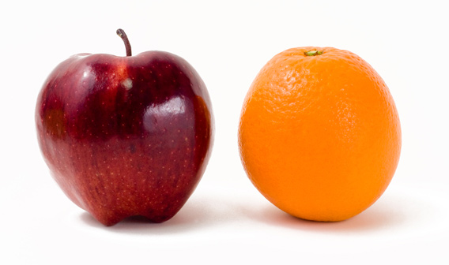

- At circle time, talk about breakfast and what kinds of foods are considered breakfast foods. Provide magazines to children and have them tear out pictures of breakfast food types. Create a group collage of breakfast foods by gluing them on poster board.

- Have children look through magazines and find pictures of different kinds of bread and fruit, as well as pictures of glasses or cartons of milk. Now give each child a large paper plate and let them glue their "breakfast" onto their paper plate.

To help children experience and make a connection to fruit in its different forms, choose two different fruits and do the following activities:

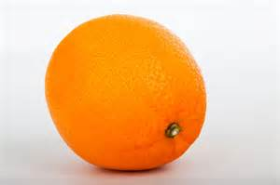

Take a whole orange, name the fruit and pass it around to each child. Have the children feel the orange ski n and describe how it feels. Then have them smell the orange and have them describe how it smells. Now peel the orange and let them see how it is different once the skin is gone. Using a hand held juicer or just by squeezing the orange create some juice, explain that the orange juice they drink which comes from a carton is made from oranges which have been squeezed. Try to squeeze enough oranges so that each child can taste some juice.
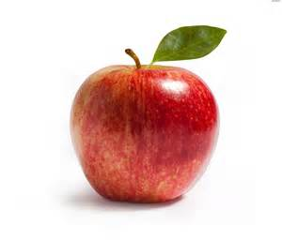

Take a whole apple, name the fruit and pass it around to each child. Then have them feel the apple skin and describe how it feels. Next have them smell the apple and let them describe the smell of the apple. Now, peel the apple, let them observe the change in appearance. Slice some apple and place into a small saucepan, add a little water and a teaspoon of lemon juice and simmer over low heat until the apple is soft. Once cool, show the children the change in texture. Now mash the apple and add a little cinnamon, explain to the children that by cooking the apple they have made applesauce. Let each child sample some or make enough to serve with break-
fast the next day.
Baked Bananas
6 servings
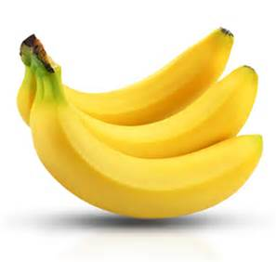

Ingredients:

6 firm and ripe bananas - peeled and into 3 inch chunks
- 3 Tablespoons butter
- 2 Tablespoons fresh lemon juice
- 3 Tablespoons brown sugar
- 1 teaspoon cinnamon
- grated coconut
- orange of lemon zest

Directions:

Place butter and lemon juice in shallow baking dish. Place in oven only until butter is melted. Stir butter and lemon juice together until mixed. Put banana chunks in baking dish and turn until bananas are well coated. In a small bowl stir together brown sugar mixture on top of bananas. Bake 18 minutes or until bananas are heated through and butter just begins to bubble. Do not overcook.

Place bananas in small serving dishes. Sprinkle small amount of grated coconut and zest over each. Serve immediately.

Note: To make this recipe a USDA approved breakfast serve with:
- Milk
- Whole Wheat Toast

Banana Burritos
4 servings

Ingredients:
- 2 bananas cut in half then cut into small pieces, separate into four equal servings
- 1 cup applesauce
- 4 Whole Wheat flour tortillas (microwave tortilla for 15 seconds on med-high to soften)
- 4 teaspoons 50/50 cinnamon and sugar mixed

Directions:

Spread each tortilla with 1/4 cup of applesauce; sprinkle each tortilla with a serving of the cut up bananas and 1 teaspoon of the cinnamon/sugar mix. Roll tortilla. Also, consider other ingredients like peanut butter (if no peanut allergies), or chopped apple. This is a fun finger food that children can help make and any combination of fruit can be used.
Note:
To make this recipe a USDA approved breakfast serve with:
- Milk
- Banana/ applesauce
- Flour Tortilla

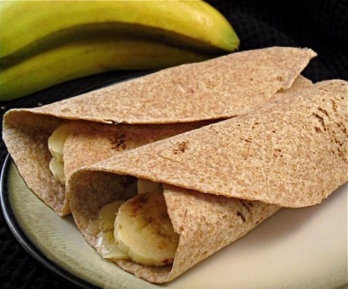
Apple Toast
4 servings

Ingredients:
- 6 Slices of either oatmeal or whole wheat bread
- 3 apples-peeled-cored-sliced
- ½ cup sugar
- 1 stick of melted butter

Directions:

Butter a baking dish. Put the slices of bread in the baking pan so that bread lays flat. Mix the sugar and melted butter together.

Dip each slice of apple in the melted butter/sugar mixture. Arrange slices of apple on top of slices of bread. Put baking dish in oven, set at 350 degrees.

Bake for about 10 minutes, or until apple slices are brown and tender. Cool slightly and serve.

Note: To make this recipe a USDA approved breakfast serve with:
- Milk
- Apple Slices
- Whole wheat/oatmeal bread

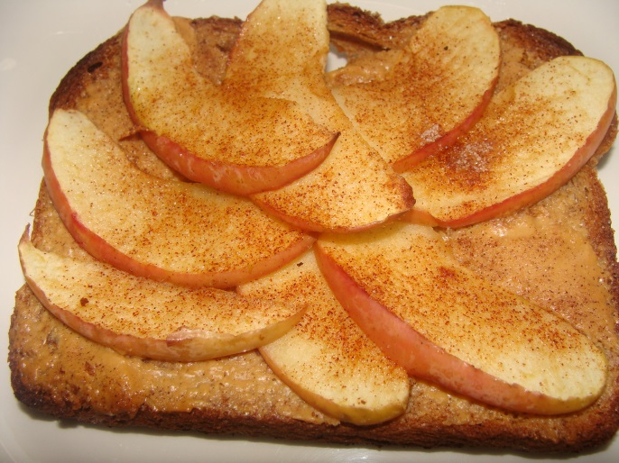

Blueberry Breakfast Bake
6 servings

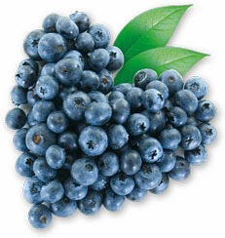
Ingredients:

- 1 & ½ cups fresh or frozen blueberries
- 8 slices of bread cut into 1 inch cubes
- 8 oz. chilled cream cheese cut into 1/8 inch cubes
- 8 eggs

Directions:
Lightly grease a baking dish (11x7 and 2 inch deep is best). Spread ½ of the bread into the pan. Sprinkle with cream cheese cubes, blueberries and remaining bread.

In a separate bowl combine eggs & milk and beat till well blended. Pour over bread mixture and cover tightly with aluminum foil. Refrigerate for at least 8 hours but no more than 24 hours.

Preheat oven to 350 degrees. Bake covered for 30 minutes, uncover and bake for 25-30 more until top is puffy and center is set. This recipe can be varied by using a different kind of berry or other fruit cut up into bite sized pieces. Blueberries are very high in antioxidants.

Note: To make this recipe a USDA approved breakfast serve with:
- Milk
- Half of one banana. (Extra fruit is required because the blueberries in the recipe aren’t quite enough fruit to fully qualify as a fruit serving for 3-12 year olds.)

Fruit Kabobs
4 servings

Ingredients:
- 1 apple
- 1 banana
- 1/3 cup red seedless grapes
- 1/3 cup green seedless grapes
- 2/3 cup pineapple chunks
- 1.4 cup dried coconut
- 1 cup nonfat yogurt
- Thin pretzel sticks

Directions:
Prepare the fruit by washing the grapes, washing the apples and cutting them into small squares peeling the bananas and cutting them into chunks, and cutting the pineapple into chunks.

Spread coconut onto a large plate.

Slide pieces of fruit onto a pretzel sticks and design your own kabobs or if the children are too young to thread them on the pretzel, make them ahead of time. Do this until the stick is almost covered.

Hold your kabob at the ends and roll it in the yogurt so the fruit gets covered. Then roll it in the coconut.

Note: To make this recipe a USDA approved breakfast serve with:
- Milk
- Bagel
*omit grapes if not age appropriate and substitute with strawberries, kiwi or any other fruit.

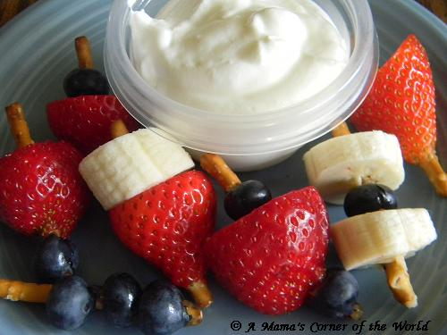

Breakfast Bonanza
Quiz

Provider Name ___________________________ Provider Number______

Group One – What have you learned?

Please circle (T) True or (F) False

- If you don’t get enough calcium in your diet, your body will take the calcium it needs from your bones. T F

- If you don’t get enough Vitamin D in your diet, or if you don’t get enough exposure to sunlight, you may not have enough Vitamin D to maintain healthy bones and teeth.
T F
- Vitamin C, also known as Ascorbic Acid, helps maintain healthy gums. T F

- A proper diet including adequate Calcium and Vitamin D is the only way to ensure life-long healthy bones. T F

- Everyone needs the same amount of Vitamin C. T F

- There are many foods that naturally contain Vitamin D. T F

- Everyone needs the same amount of Vitamin D. T F

- Calcium is important only for adult women. T F

- Vitamin C is present in Broccoli. T F

- Everybody needs the same Vitamins. T F

Breakfast Bonanza
Quiz

Provider Name ___________________________ Provider Number______

Group two-What have you learned?

Please circle (T) True or (F) False

- Creating a collage of breakfast foods is a good way to help children identify healthy food.
T F

- Introduce a new food at the end of the meal so that if the child doesn’t like it they will already have eaten something. T F

- When you let the children help you to prepare a new food they may be more incline to try it. T F

- If a child refuses a new food, wait about a month before trying it again. T F

- Children transition very quickly from eating sweet foods to whole grain. T F

- When a child rejects a new food it usually means they don’t like it. T F

- Milk at breakfast must always be fluid milk. T F

- Never mix pancake batter the night before. T F

- Children don’t like foods that are too mushy. T F

