**CACFP New Meal Pattern**

**Training FY 2017/2018**

**2 Hours Nutrition**

In accordance with Federal civil rights law and U.S. Department of Agriculture (USDA) civil rights regulations and policies, the USDA, its Agencies, offices, and employees, and institutions participating in or administering USDA programs are prohibited from discriminating based on race, color, national origin, sex, disability, age, or reprisal or retaliation for prior civil rights activity in any program or activity conducted or funded by USDA.

Persons with disabilities who require alternative means of communication for program information (e.g. Braille, large print, audiotape, American Sign Language, etc.), should contact the Agency (State or local) where they applied for benefits. Individuals who are deaf, hard of hearing or have speech disabilities may contact USDA through the Federal Relay Service at (800) 877-8339. Additionally, program information may be made available in languages other than English.

To file a program complaint of discrimination, complete the USDA Program Discrimination Complaint Form, (AD-3027) found online at: http://www.ascr.usda.gov/complaint_filing_cust.html, and at any USDA office, or write a letter addressed to USDA and provide in the letter all of the information requested in the form. To request a copy of the complaint form, call (866) 632-9992. Submit your completed form or letter to USDA by:

(1) mail: U.S. Department of Agriculture

Office of the Assistant Secretary for Civil Rights

1400 Independence Avenue, SW

Washington, D.C. 20250-9410;

(2) fax: (202) 690-7442; or

(3) email: [program.intake@usda.gov](mailto:program.intake@usda.gov).

This institution is an equal opportunity provider.’

**Resources -** Denise Courtney, Massachusetts Department of Elementary and Secondary Education (ESE)

Office for Food & Nutrition Programs December 2016, Team Nutrition [www.teamnutrition.usda.gov](http://www.teamnutrition.usda.gov). April 2017

One hundred percent of the funding for this program and publication is provided by USDA and, therefore, any

publications may be freely copied by USDA, the Office for Food and Nutrition Programs, and by any other institutions under the Child and Adult Care Food Program.

[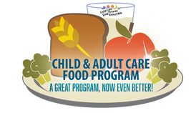](http://www.google.com/url?sa=i&rct=j&q=&esrc=s&source=images&cd=&cad=rja&uact=8&ved=0ahUKEwiEvqvP__zVAhUCPBQKHV-0DrUQjRwIBw&url=http://ccfprtconference.weebly.com/cacfp-meal-pattern-implementation-library.html&psig=AFQjCNH4WTYOVMZxrGaCR9_lHErz_pv7Cw&ust=1504115032820137)

**Goals**

Understand the major changes outlined in the new Child and Adult Care Food Program meal pattern.

This training will provide you with:

* Changes to meal components
* Fruits
* Vegetables
* Meat/Meat Alternate
* Grains
* Fluid milk
* Meal Pattern
* Meal Ideas
* Test your knowledge

**Foundation of a healthier generation**

This is the first major revision since 1968. Why? Reflects updates in nutrition science. New goal: To prevent overconsumption of calories, saturated fat, added fats, added sugar, and under consumption of fiber and other essential nutrients.

**Why is the meal pattern changing?** Healthy, Hunger-Free Kids Act requires USDA to:

* Update the CACFP meal patterns
* Align the meal patterns with: The most recent version of the Dietary Guidelines for Americans. Most recent and relevant nutrition science and recommendations from an authorized scientific agency or organization.

[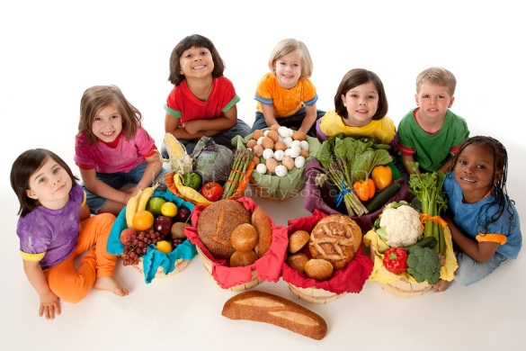](http://www.google.com/url?sa=i&rct=j&q=&esrc=s&source=images&cd=&cad=rja&uact=8&ved=0ahUKEwiepK2OhP3VAhWIVBQKHTjvBzoQjRwIBw&url=http://www.carlostevezfans.info/uaehcrv-healthy-child.asp&psig=AFQjCNGL-kPlMVDSskthd31-ObBabCJn6g&ust=1504116324608158)

**Background Terms**

* **Food Components:** One of the food groups that comprise a reimbursable meal
* **Food item:** A specific food offered within the food component comprising the reimbursable meal.
* **Creditable:** Food items that may be counted toward meeting the meal pattern requirement for a reimbursable meal.
* **Reimbursable meal:** A meal that meets the minimum meal pattern requirements and eligible for reimbursement when served in the CACFP.

**Food Components**

There are now **five (5)** meal components:

1. Fruit
2. Vegetable
3. Grain
4. Meat/Meat Alternate
5. Fluid Milk

Required food components Old vs. New.

Meal Type **- Breakfast (old) Breakfast (new) 3 meal components required**

Bread or Alternate Grain or Meat

Juice or Fruit or Vegetable Fruit or Vegetable

Fluid Milk Fluid Milk

**Lunch/Dinner (old) Lunch/Dinner (new) ALL 5 meal components required**

Meat or Alternate Meat

Bread or Alternate Grain

Fruit or Vegetable Vegetable

Fruit or Vegetable Fruit

Fluid Milk Fluid Milk

**Snack (old) pick 2 of 4 Snack (new) Pick 2**

Meat or Alternate Meat

Bread or Alternate Grain

Juice or Fruit or Vegetable Fruit

Fluid Milk Vegetable

Fluid Milk

[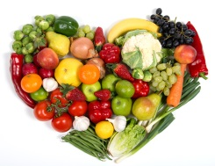](http://www.newfoundbalance.com/fruits-and-vegetables-getting-to-the-root-of-the-problem/)

**Fruits and Vegetables**

Separate components at Lunch, Dinner and Snack: Two (2) **DIFFERENT** vegetables can be served at Lunch and Dinner.

Example – Apples & Carrots **NOT** Apples & Pears

Carrots & Broccoli **NOT** Broccoli & Broccoli

Consider your fruit and vegetable carefully in menu planning.

**Fruits:**

* 1/8 cup/2 TBS minimum per serving
* 100% dried fruit is creditable
* **SNACK CHIPS NOT CREDITABLE**

**Juice:**

* 100%
* Fruit is listed as 1st ingredient
* Comprise the entire fruit component
* **ONLY ONCE PER DAY**

Fruits that are whole, sliced pureed, dried and sliced are easier for children to eat reduce food waste and can be prepared in the family day care area.

**Vegetables:** Raw, cooked or mashed. Great snack for older kids but be certain to cut into small pieces for younger children. Try different dipping sauces to increase appeal.

When making a mixed dish ensure full vegetable portion is served and remember to add flavor to vegetables. Vegetable juice is 100%. Vegetable listed as 1st ingredient. Comprise the entire vegetable component.

**Vegetables or Meat Alternate:** Beans (Black, Kidney, Chickpea, Pinto, etc. Peas (Green, Black-eyed, Split) and Lentils. 1oz ¼ c = Meat Alternate – Beans ¼ C vegetable.

[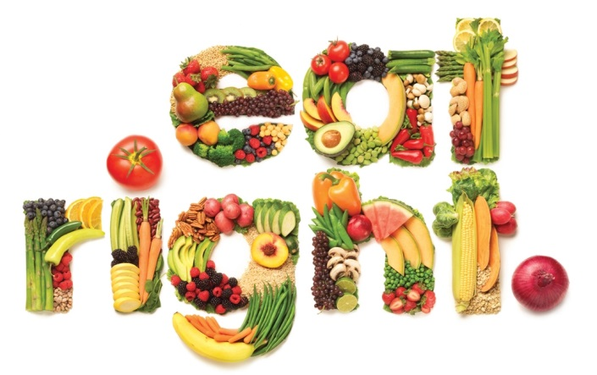](http://www.google.com/url?sa=i&rct=j&q=&esrc=s&source=images&cd=&cad=rja&uact=8&ved=0ahUKEwicz7rFk4LWAhWn5YMKHau5CYkQjRwIBw&url=http://www.real-abs.com/fitness/learn-to-eat-right-and-burn-fat/&psig=AFQjCNEHFSWzStKGl8OlOPaeErXrh_6jPQ&ust=1504292268993106)

**Grains**

At least one serving of grains per day must be **whole grain-rich.**

* 100 % whole
* Blend of whole grain and enriched meal/grain where at least 50% is whole grain

[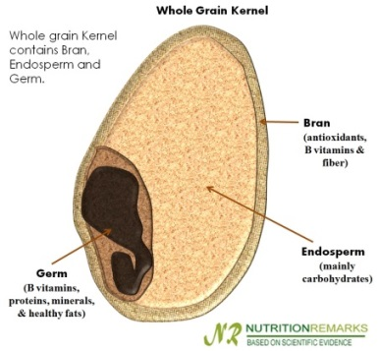](http://www.google.com/url?sa=i&rct=j&q=&esrc=s&source=images&cd=&cad=rja&uact=8&ved=0ahUKEwitus3nuYHWAhUM4oMKHZDGAu8QjRwIBw&url=http://www.nutritionremarks.com/2013/03/22/can-whole-grain-food-help-you-manage-weight/&psig=AFQjCNFgEUbi4kWVwuQIE2D6zHnyIUcPNA&ust=1504268149519948)

Whole grains consist of the entire cereal grain seed or kernel, after removing the inedible outer husk or hull. The kernel includes the starchy endosperm, the fiber-rich bran, and the nutrient-rich germ.

**Breakfast Cereals – no more than 6g of sugar per 1 oz.**

**(Refer to “Sugar Sense” flyer for a list of creditable cereals.**

[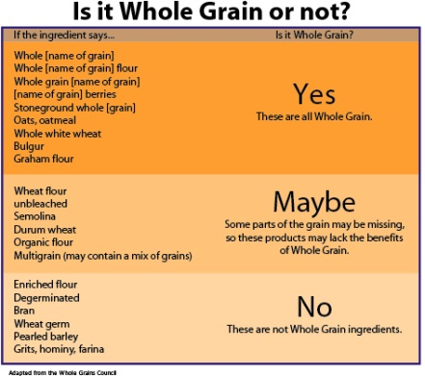](https://www.google.com/url?sa=i&rct=j&q=&esrc=s&source=images&cd=&cad=rja&uact=8&ved=0ahUKEwje7trtqoHWAhWn44MKHV9NDu4QjRwIBw&url=https://www.lapbandsurgery.com/six-weeks-to-a-healthy-diet-week-5-whole-grains/&psig=AFQjCNFbvmUgVsAyYId_Yn3Jhjqx1EaZ2Q&ust=1504264107330621)

**Whole Grain is First Ingredient:** This method is different for products that contain only the grains component vs combination foods that contain grains and other food components such as met/meat alternates and vegetables, i.e., pizza burritos, and breaded chicken nuggets.

* A **grain-only product** (such as bread and cereals) contains at least 50% whole grains if a whole grain is the first ingredient, or water is listed first and a whole grain is listed second.
* A **combination food** contains at least 50% whole grains if a whole grain I the first ingredient in the list of grains.



See Exhibits: Grain requirement for Child Nutrition Programs USDA Memo June 30, 2017

**Meat & Meal Alternatives**

* Can replace grain 3 times a week at breakfast
* Tofu can be served in ways that it can be easily recognized by children
* Yogurt sugar limit



**Choose Yogurts that are lower in Added Sugars:** As of October 1, 2017, yogurt served in the CACFP must not have more than 23 grams of sugar per 6 ounces.

[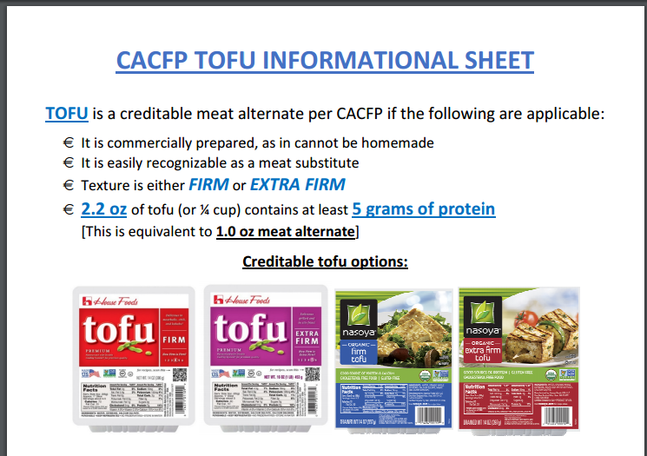](http://www.google.com/url?sa=i&rct=j&q=&esrc=s&source=images&cd=&cad=rja&uact=8&ved=0ahUKEwjLldelyYHWAhULyYMKHcKLA9wQjRwIBw&url=http://ccfprtconference.weebly.com/tofu.html&psig=AFQjCNHVDyHye-kDwSCtl2LN51PyqqGq2g&ust=1504270637540958)

**Fluid Milk**

* Whole Unflavored 12 months – 24 months
* 1% Unflavored 2 years – 5 years
* Skim/Fat Free Unflavored 2 years – 5 years
* **Skim/Fat Free Flavored* 6 years and older (school age children only)**

**The Facts on Flavored Milk:**

Flavored milk cannot be part of a reimbursable meal or snack for children 5 years old and younger.

Homemade flavored milk made by adding flavored straw, syrups, and powders to unflavored milk also cannot be part of a reimbursable meal or snack for children 5 years old and younger.

Flavored milk served to children 6 years old must be fat-free (skim).

**Menu Checklist**

* All menus must be pre-planned and posted BEFORE the meal.
* If you change a menu item the day of, you must edit the menu to reflect foods served.
* You must indicate if a grain is whole grain-rich on the menu
* You must describe the fluid milk you are serving
* Is it Whole, 1% or Fat free
* Is it flavored or unflavored

**CACFP New Meal Pattern**

**Training FY 2017/2018**

**2 Hours Nutrition Quiz**

**Provider Name ____________________ Provider Number_____**

1. List the background terms of this training: _______________________________________
2. This is the first major change since 1968? T F

2a Explain why. ________________________________________________________________________

1. Explain the difference between the **NEW MEAL COMPONENTS** and the **OLD MEAL COMPONENTS**.
2. There are now five (5) meal components: T F
3. With the new meal pattern you server separate components at Lunch, Dinner and Snack.

Example – Apples & Pears T F

Carrots & Broccoli T F

1. 100% Juice can be served at every Snack T F
2. How often can Juice be served? Once a day? At every meal? Snack only?
3. Vegetables or Meat Alternate: What is the serving size for Vegetable? _______________

What is the serving size for meat Alternate: __________________?

1. How much grain per day should be served? 1 serving 4 servings
2. When choosing blend of whole grain and enriched meal/grain there should be at least:

100% 75% 50% 25%

1. At least one serving of grains per day must be whole grain rich? T F
2. Test Yourself – on the “Choose Breakfast Cereals that are lower in Added Sugars “complete the TEST YOURSELF: and return with this training quiz.
3. Breakfast Cereal must contain no more than 6 gram of sugar per 1 oz. T F
4. Test Yourself – on the “Choose Yogurts that are lower in Added Sugars “complete the TEST YOURSELF: and return with this training quiz.
5. Flavored milk is now creditable as a reimbursable meal for children under 5 years old? T F
6. Try it Out! Milk Matters. Complete the Milk Matters quiz **QUESTION 1 & 2 ONLY** and return with this quiz.
7. Create two (2) meals and one snack using your selected creditable food item.

* Be specific, indicate which meal component each food item credits for
* Try giving your dish a fun name
* What lesson could you teach child around your selected food item.